Design DB Model for Guvi Zen Class

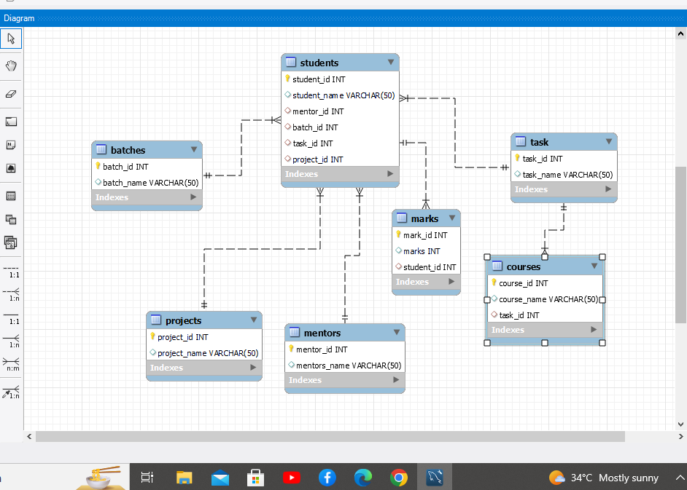

# Code:

create table mentors(mentor_id int primary key,mentors_name varchar(50));

create table batches(batch_id int primary key,batch_name varchar (50));

create table task(task_id int primary key,task_name varchar(50));

create table projects(project_id int primary key,project_name varchar (50));

create table courses(course_id int primary key,course_name varchar (50),task_id int,

foreign key(task_id) references task(task_id));

create table students(student_id int primary key,student_name varchar(50),mentor_id int

,batch_id int,task_id int,project_id int,

foreign key(mentor_id) references mentors(mentor_id),

foreign key(batch_id) references batches(batch_id),

foreign key(task_id) references task(task_id),

foreign key(project_id) references projects(project_id)

);

create table marks(mark_id int primary key,marks int,student_id int,

foreign key(student_id) references students(student_id)

)